|  |  |  |  |  |  |
| --- | --- | --- | --- | --- | --- |
| Date | 11-Dec-22 | | | Tester Name | Mohammad Yusuf |
| Environment | Penfax - Test | | | Login used |  |
| Operating System | Windows | Version: | Update: | | |
| Software Used | Edge | Version: | Update: | | |
| Not Applicable | Version: | Update: | | |
| Release version |  | | | | |
| Title | E7 Fund Transfers | | | | |
| Test Type | Regression | | | | |
| Test Scenario | E7.08 Process a transfer of all funds from 1 account to a different account and Change the Deposit Allocation Instructions - PENWEB | | | | |
|  |  | | | | |
| Expected Results | 1. Interfund Transfer should be processed and displayed under member’s account in Penfax and in Member PLANet. 2. PEPP Interfund Transfer Letter should be available. 3. Transcation should be listed on the Daily Valuation Report. | | | | |
| Pass/Fail | Pass | | | JIRA# | N/A |

Describe your steps with screenshots:

1. Go to Member Search -> Filter to Plan PEPP, Member Type Employee and Member Status to Active.

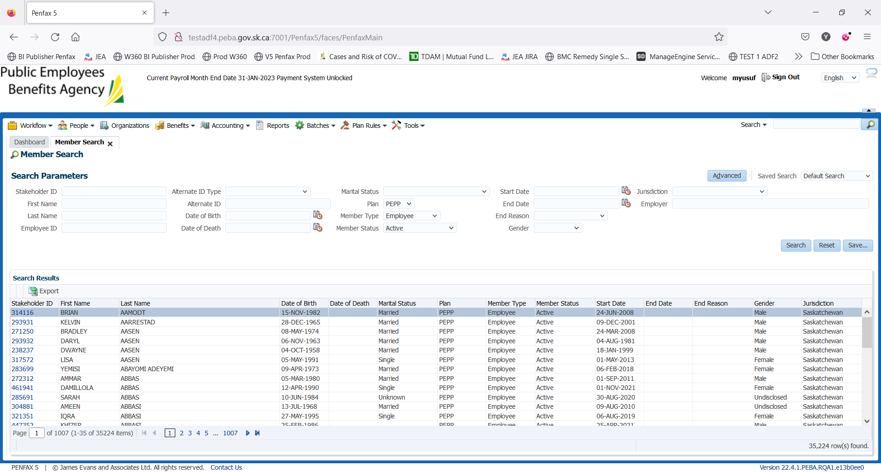

1. Click on one of the Stakeholder IDs.

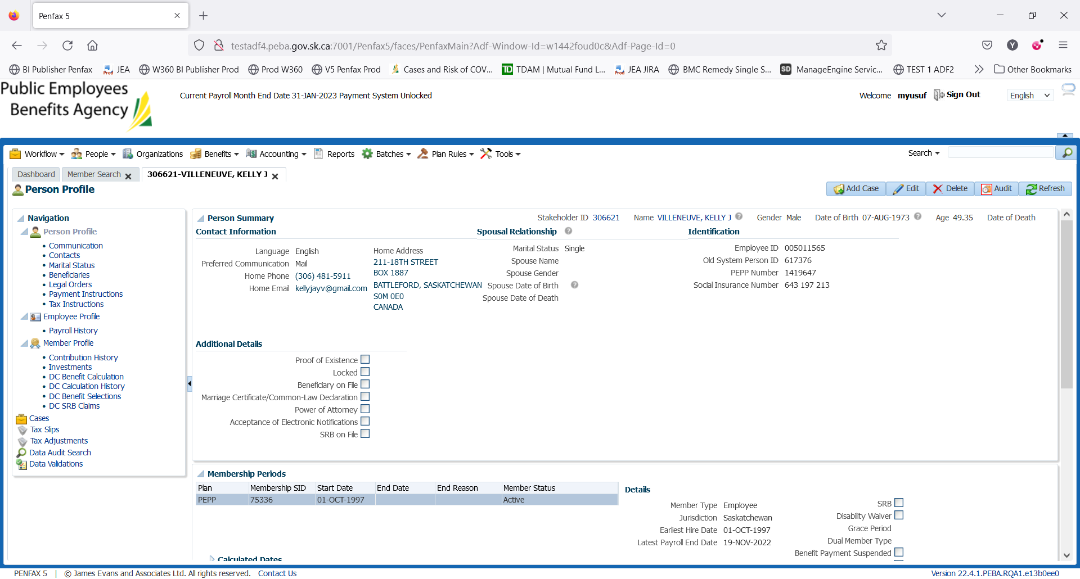

1. Click on Investments on the Navigation panel. Scroll down and open up the Account Instructions Tab. Take note of what the current instructions are. Here, the current deposit allocation is 100% in PS4. Click Add.

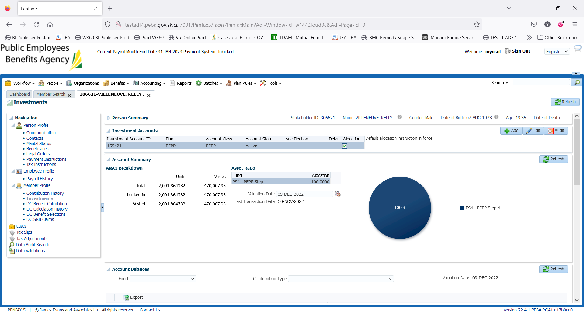

1. Member PLANet -> current allocation

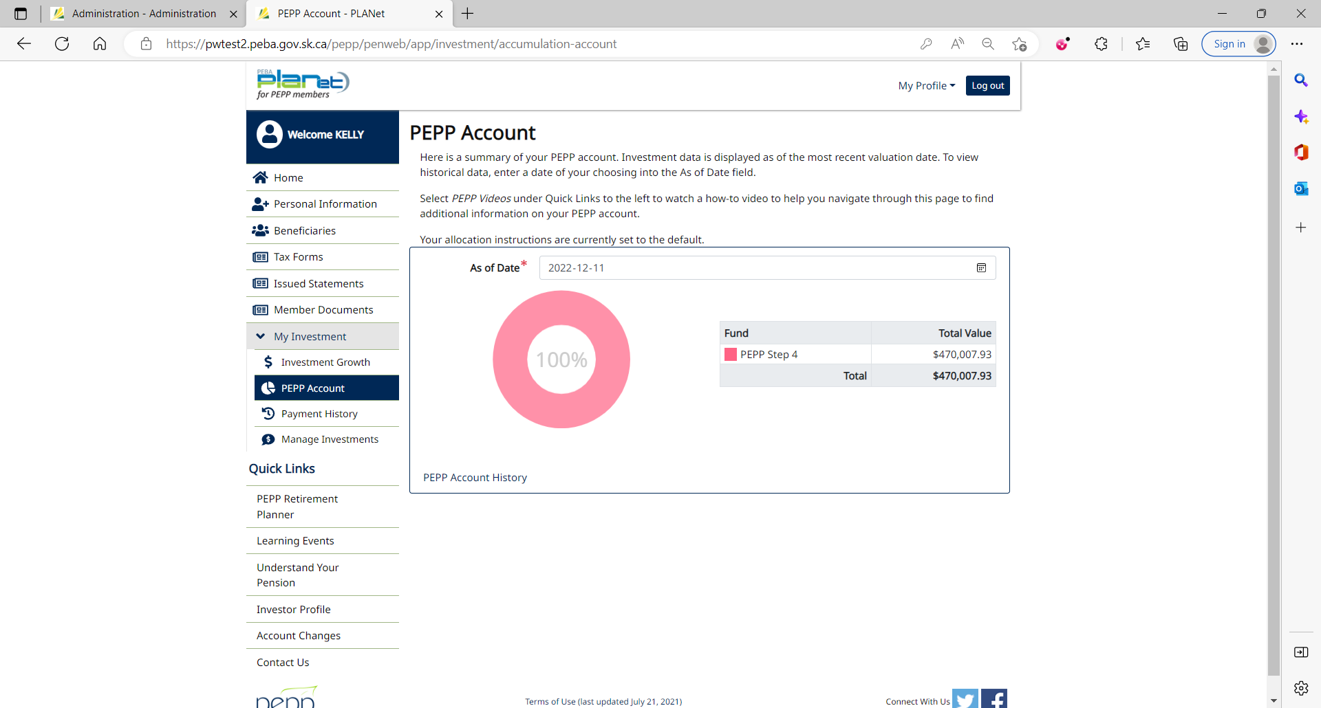

1. Go to Manage Investments to do interfund transfer.
2. Click on Change My Investment Options.

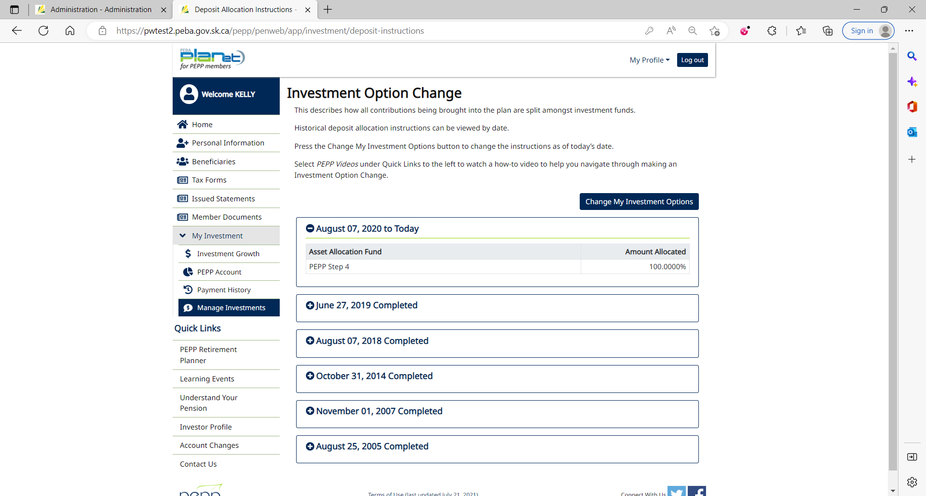

1. Click Yes.

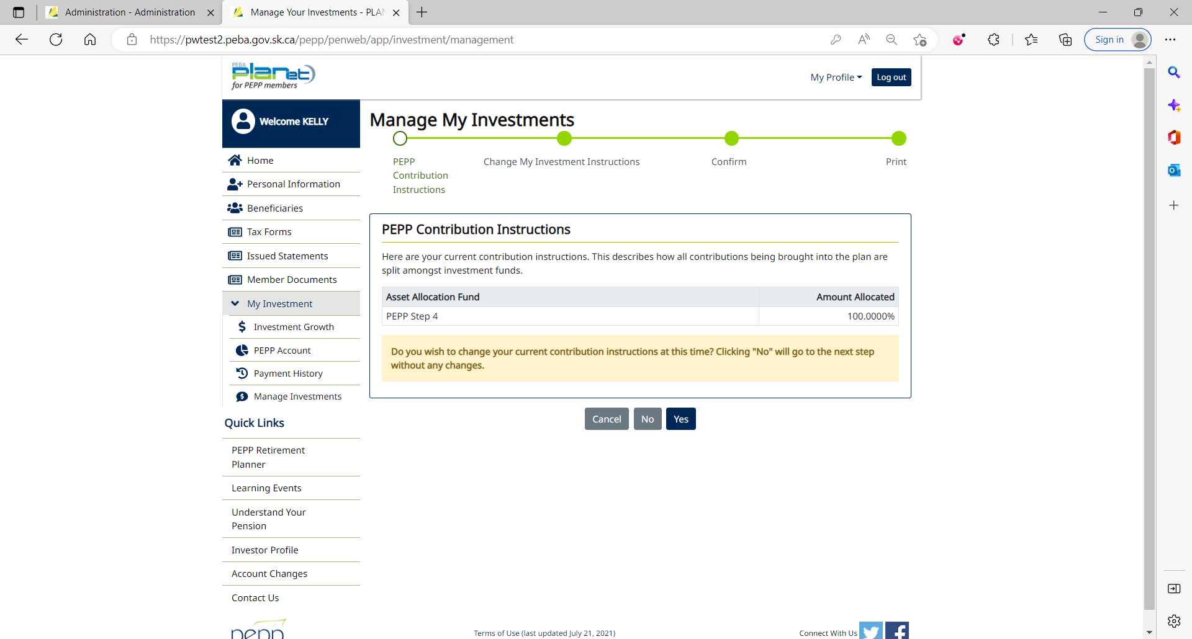

1. Current Contribution Instruction

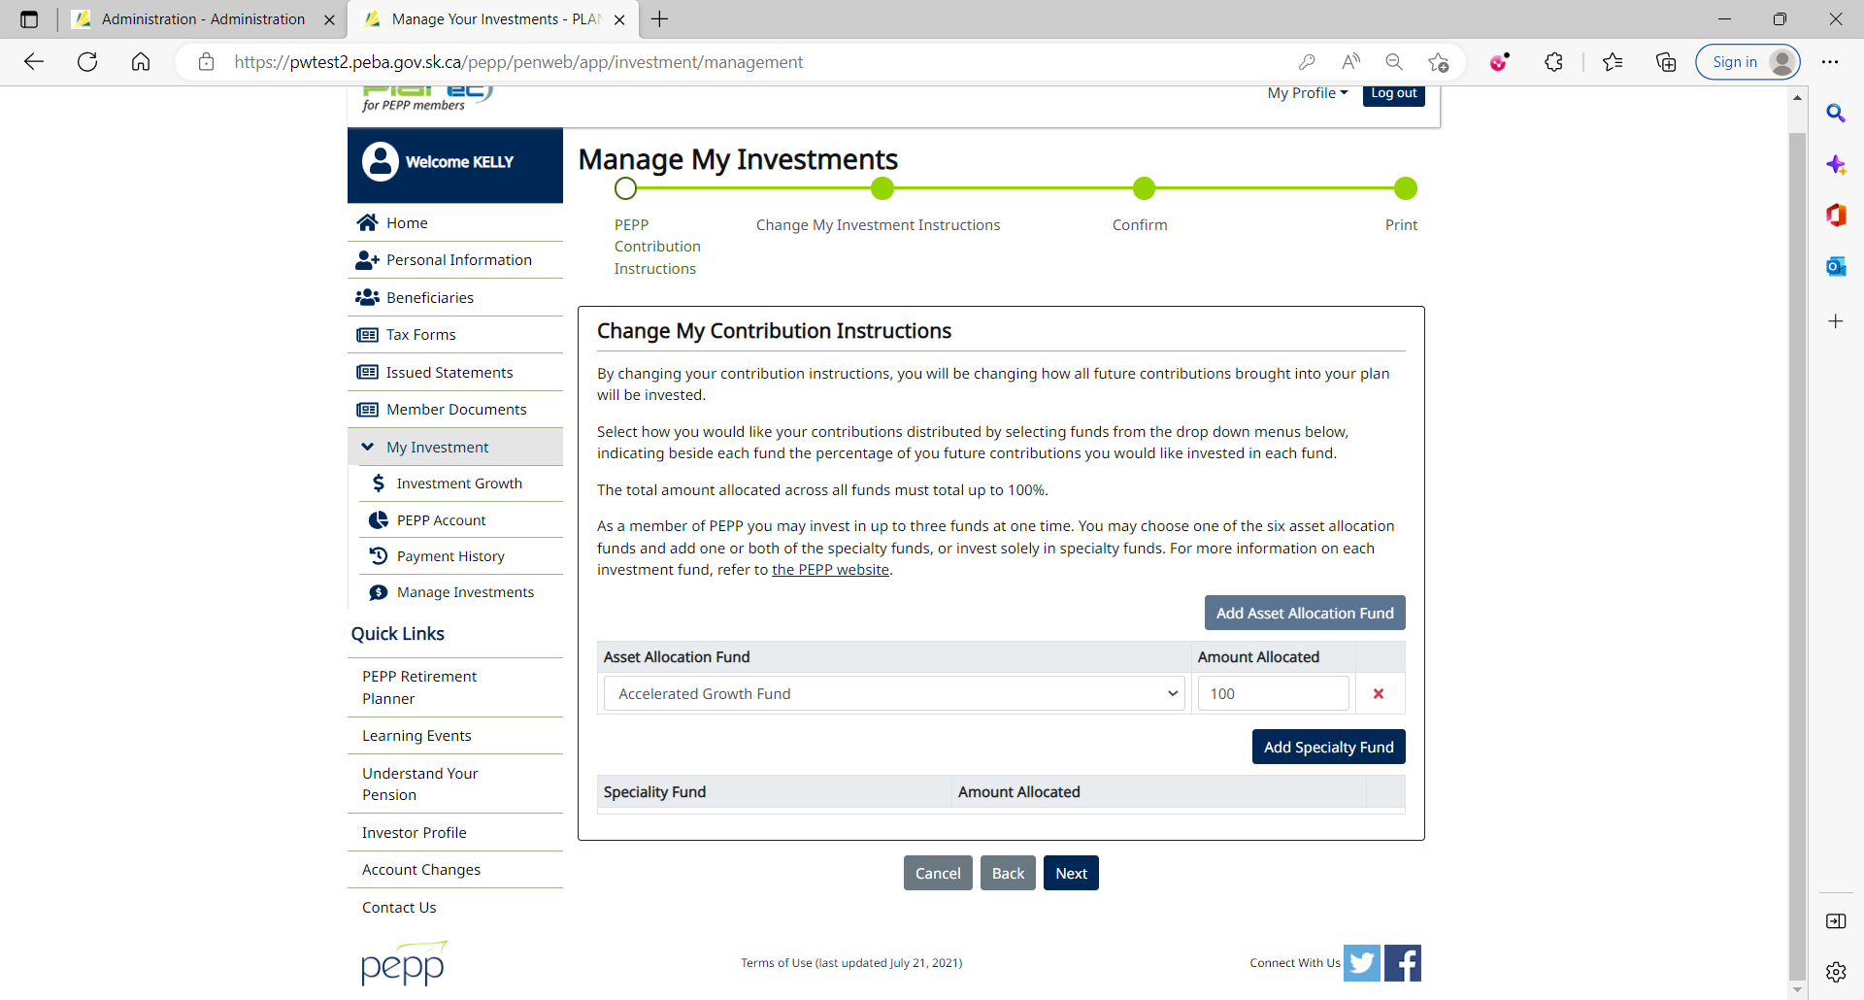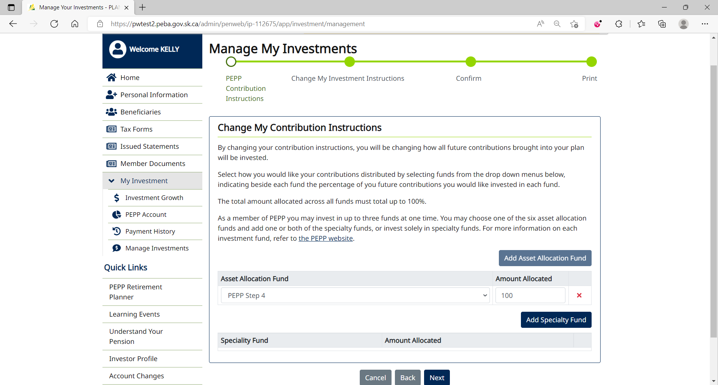

1. Select the fund to which you want to transfer money and input the amount allocated. Click Next.

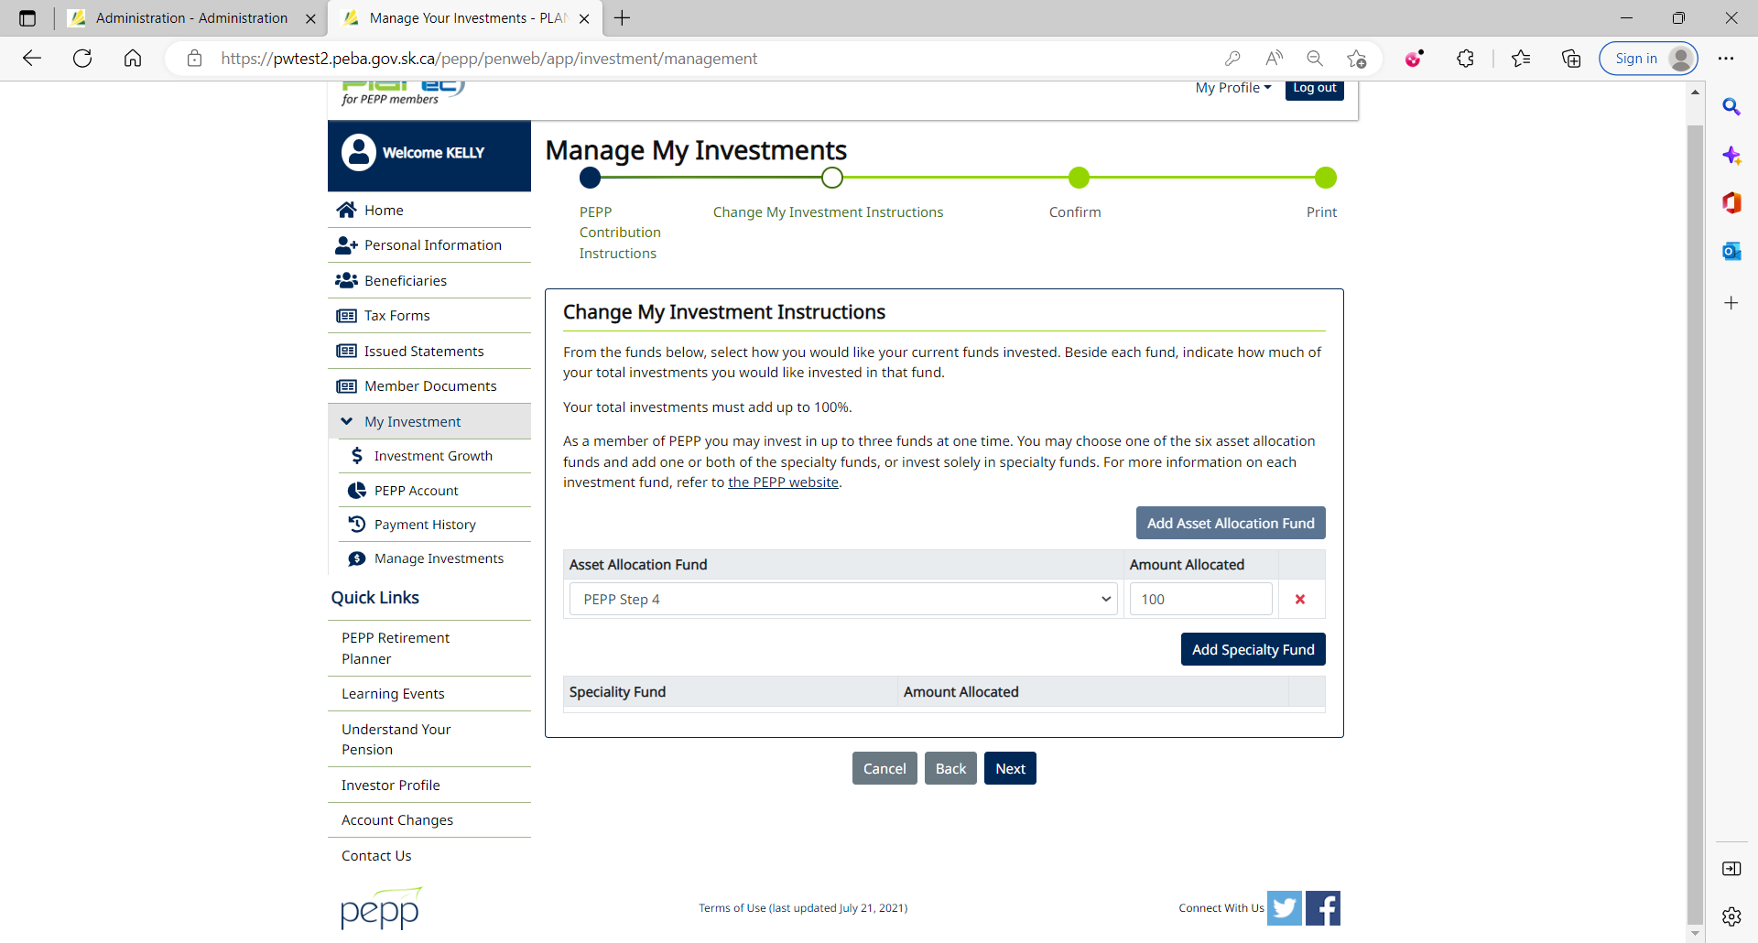

1. Click Yes.



1. Select the fund to which you want to transfer money and input the amount allocated. Click Next
2. Tick the checkbox and click Confirm.

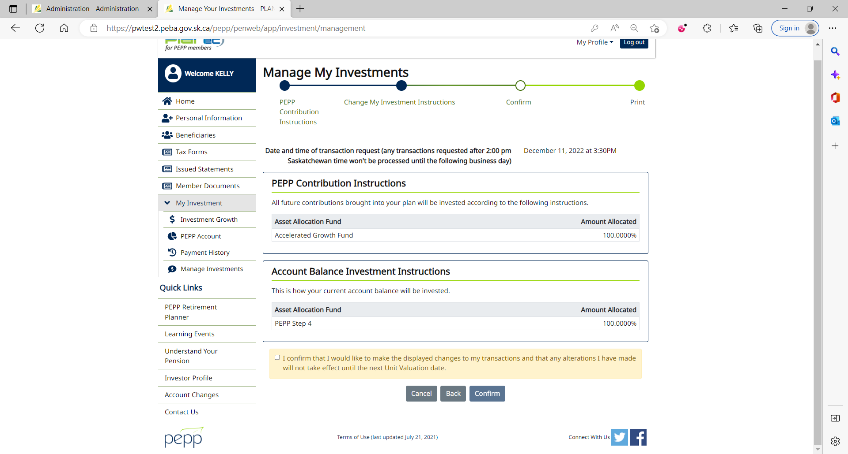

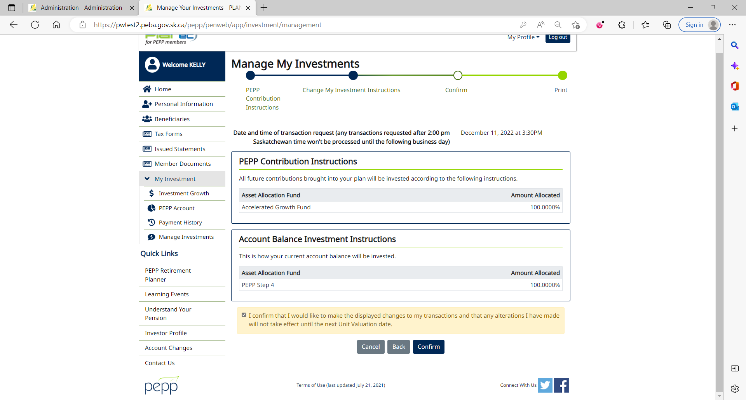

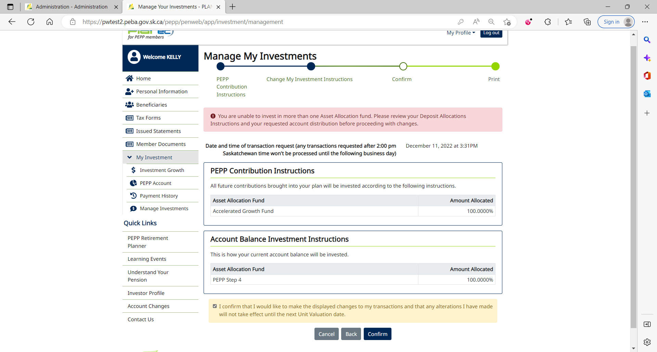

Received a valid error. Negative test passed.

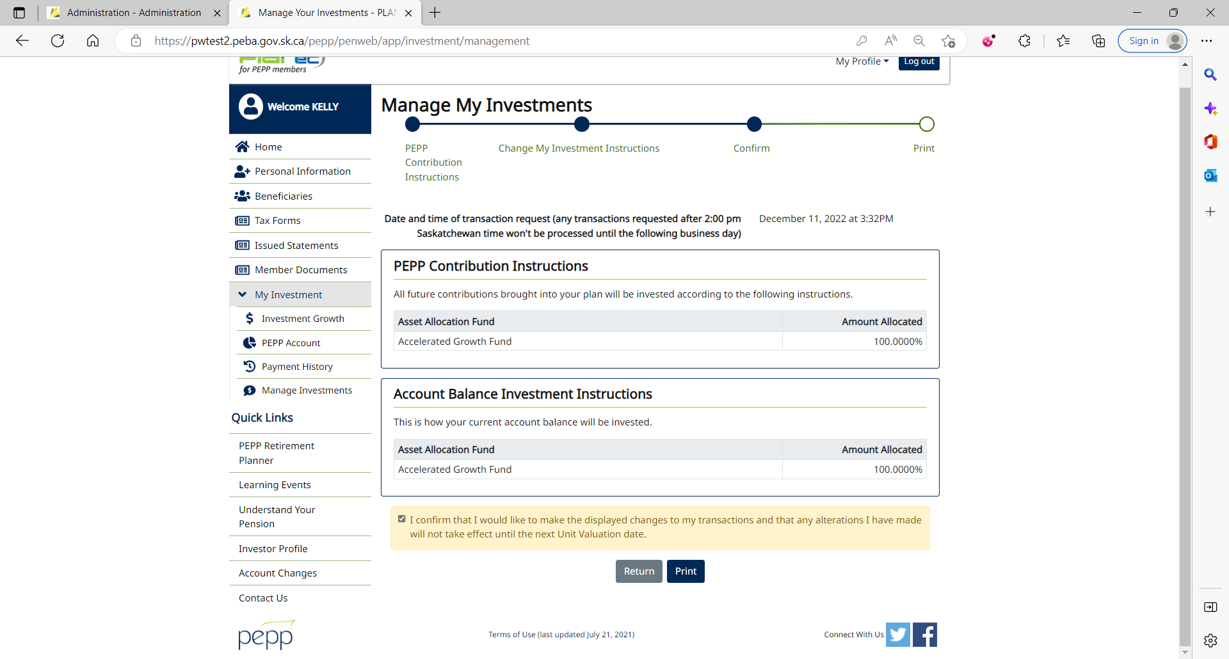

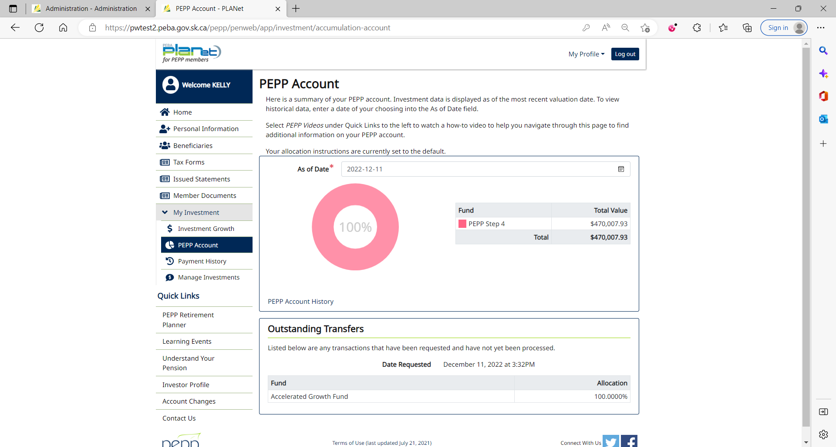

1. Deposit Allocation and Interfund Transfer can immediately be seen under Account Instructions in Penfax with the Pending status.

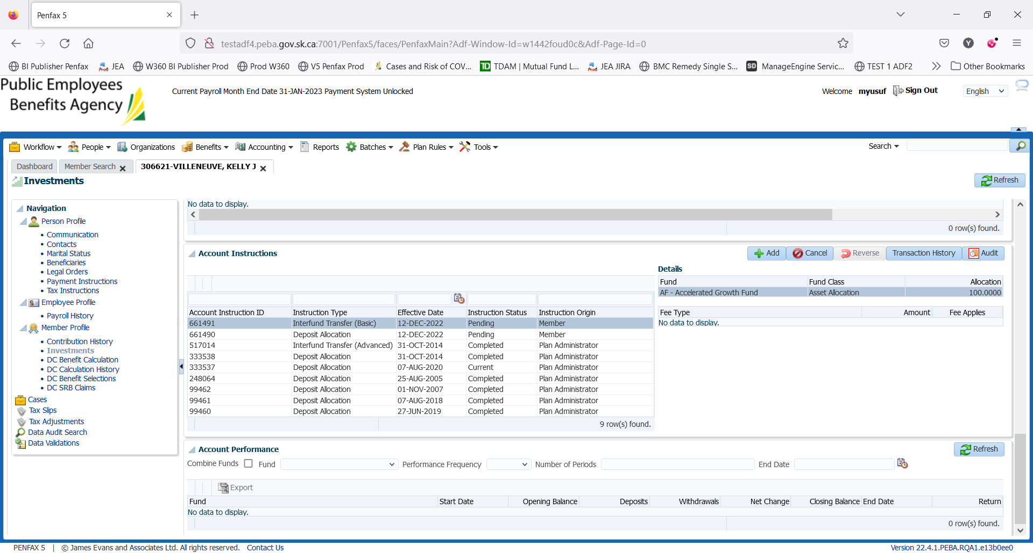

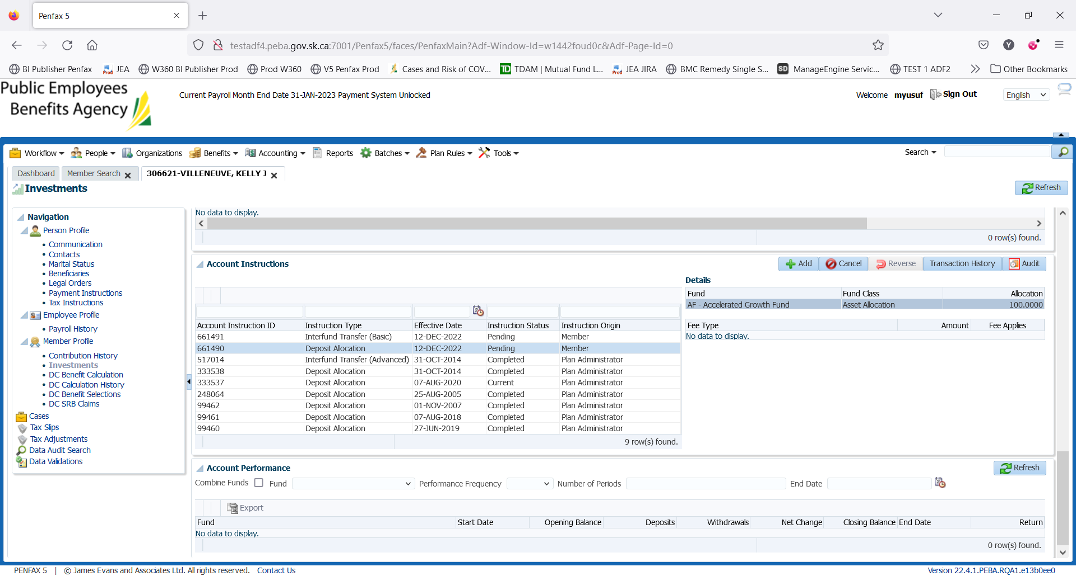

DAY 2 Validation

1. PIT batch was run overnight.
2. New DAI is now in current status but as Interfund Transfer was done in Member PLANet yesterday (May 25, 2022) after 2 pm, it will be processed on next day (May 26, 2022).

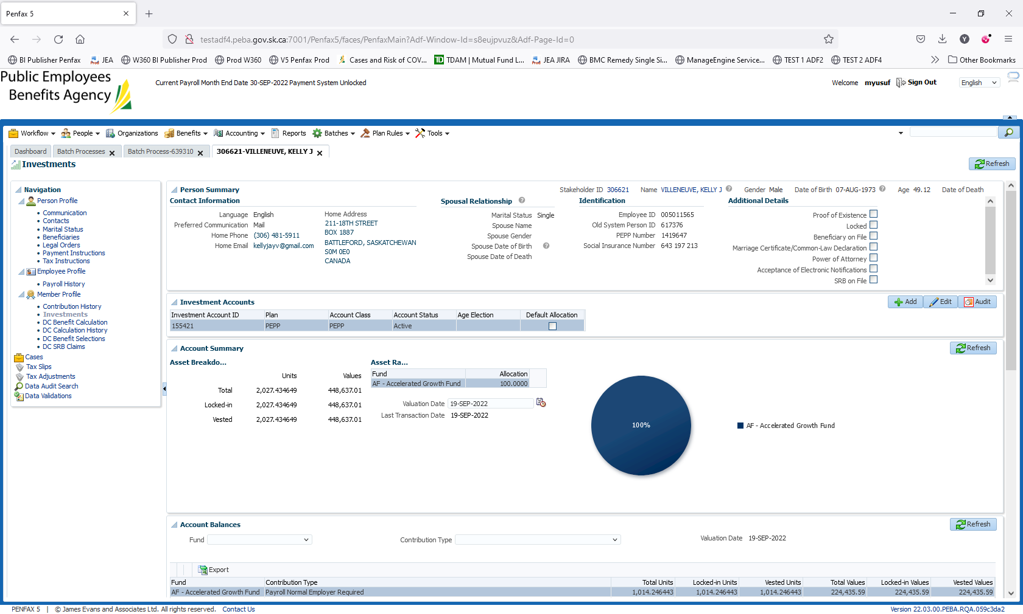

Transaction History of Interfund Transfer

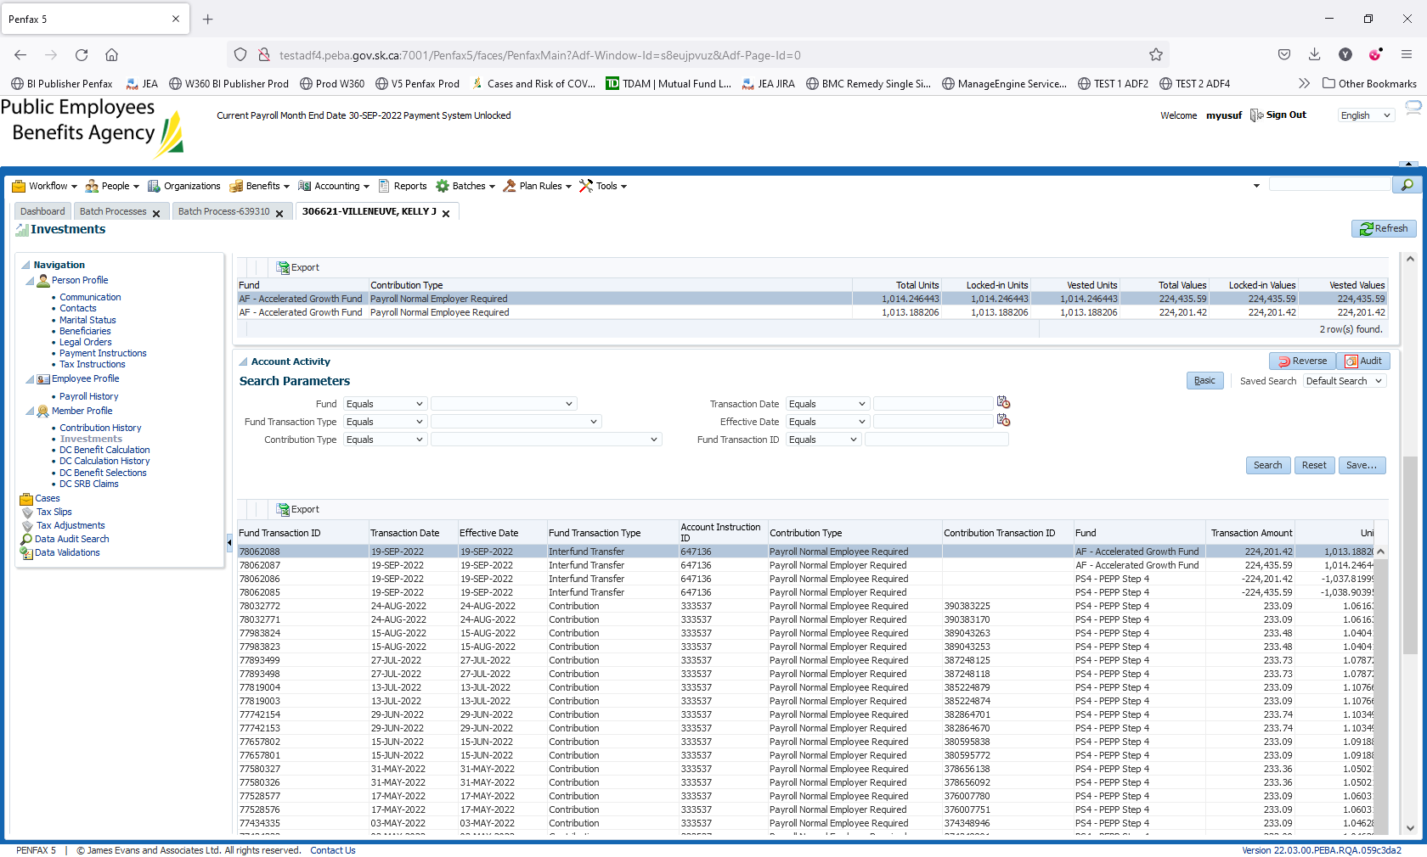

1. PEPP Interfund Transfer letter is available under Person Profile -> Communication -> Outbound Documents.

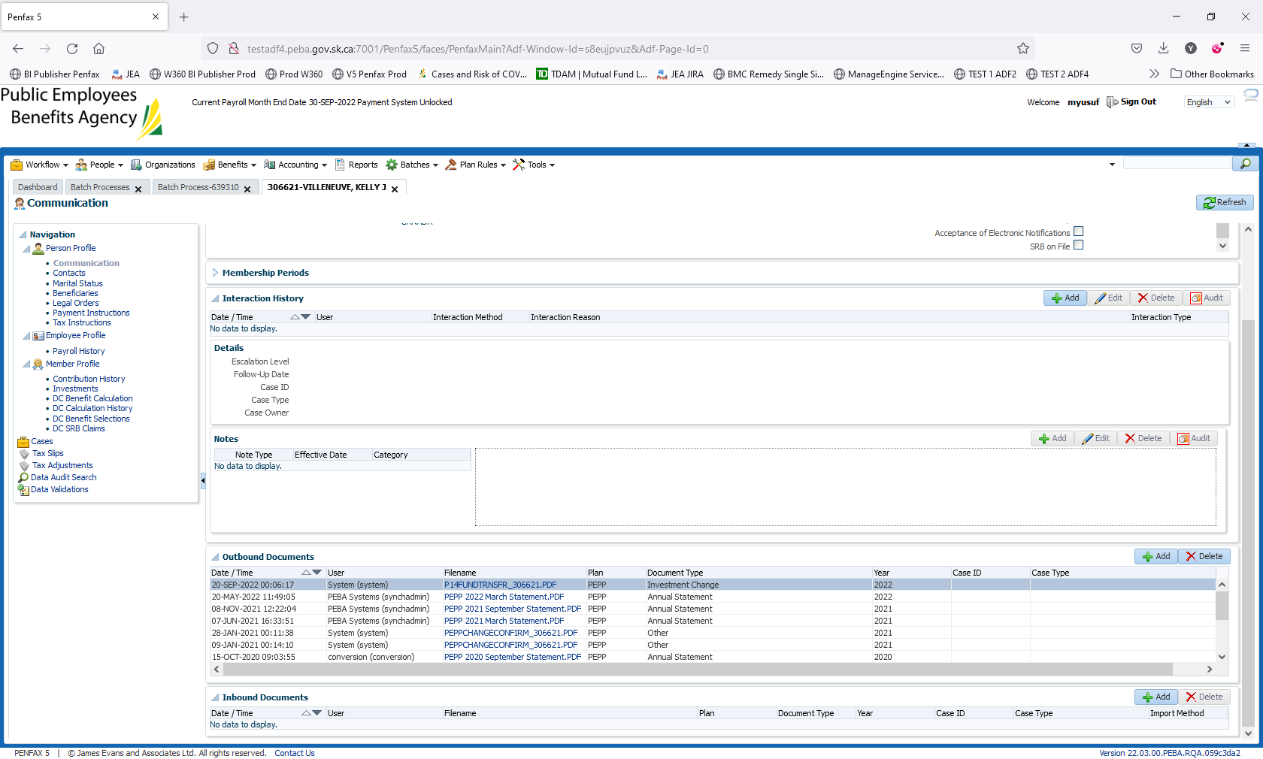

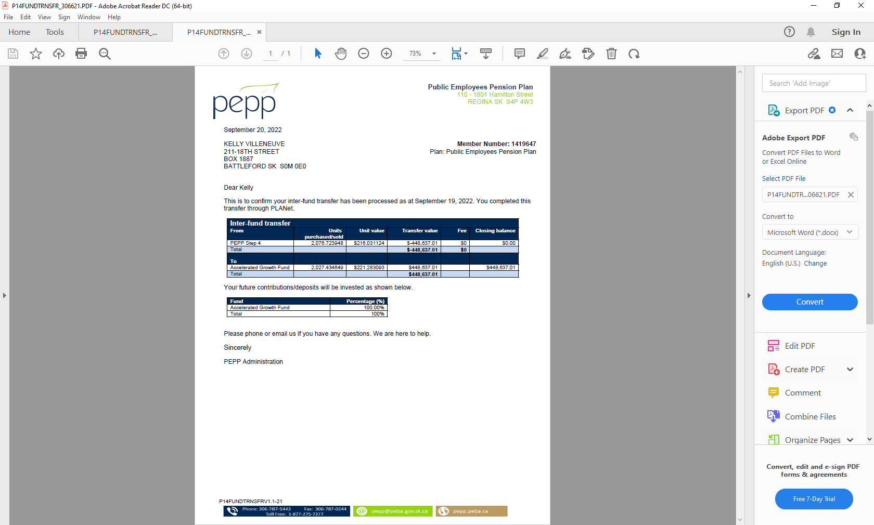

1. Check the Valuation Report. Go to Batches -> Batch Processes. Search with “PEPP Valuation Report” as Batch Process Type and open the very first record in the list (batch processed a day before).

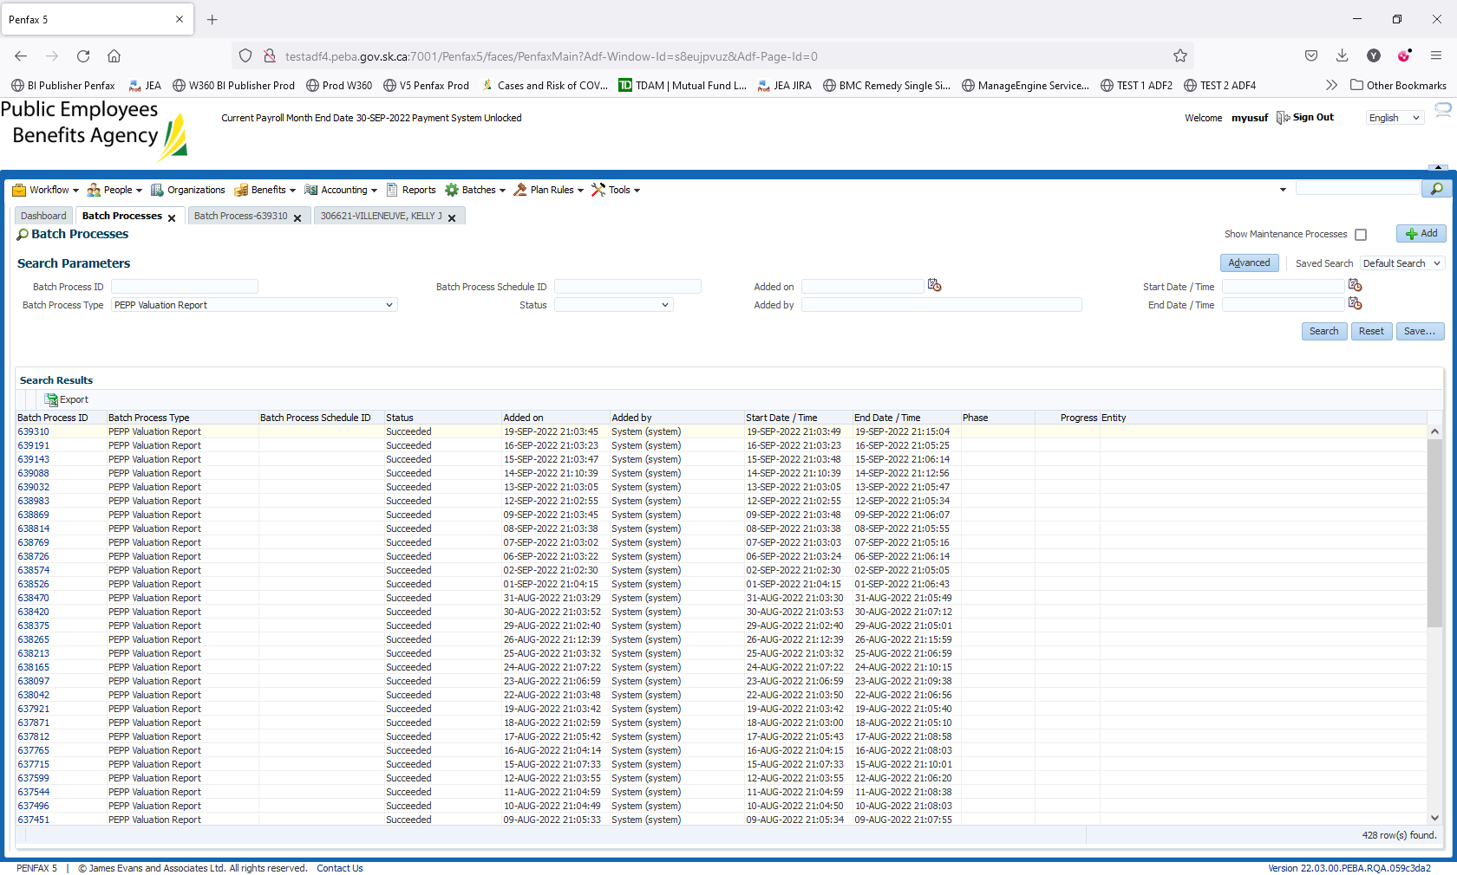

Go to Files tab and open PEPP valuation excel.

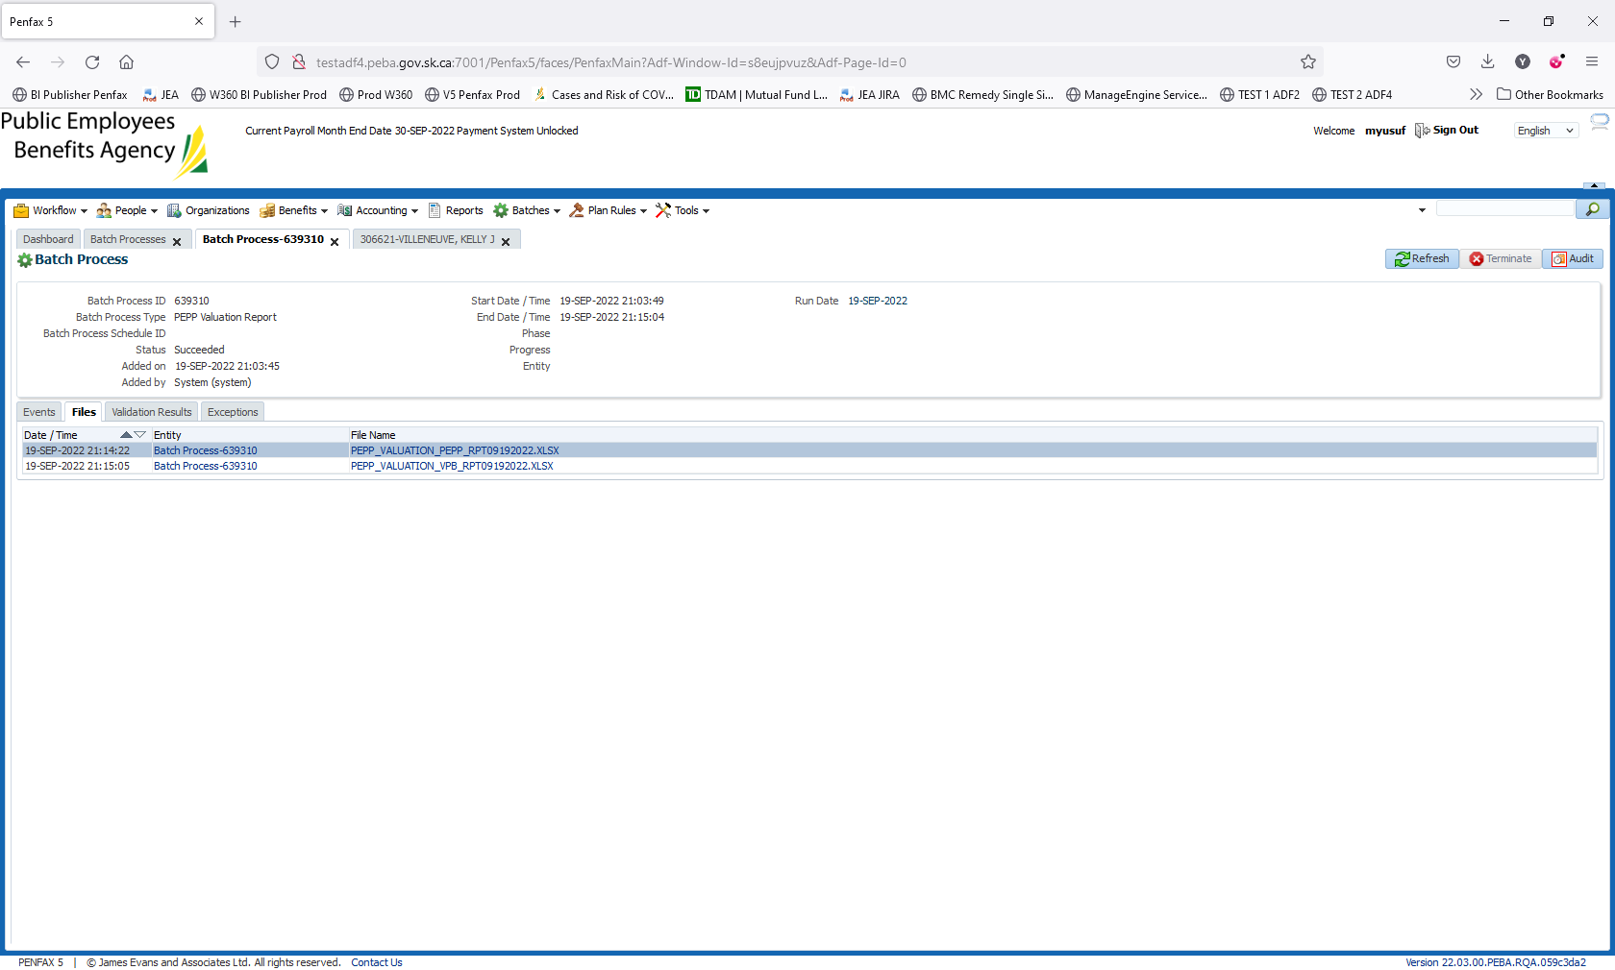

Section Four (Transfer In)

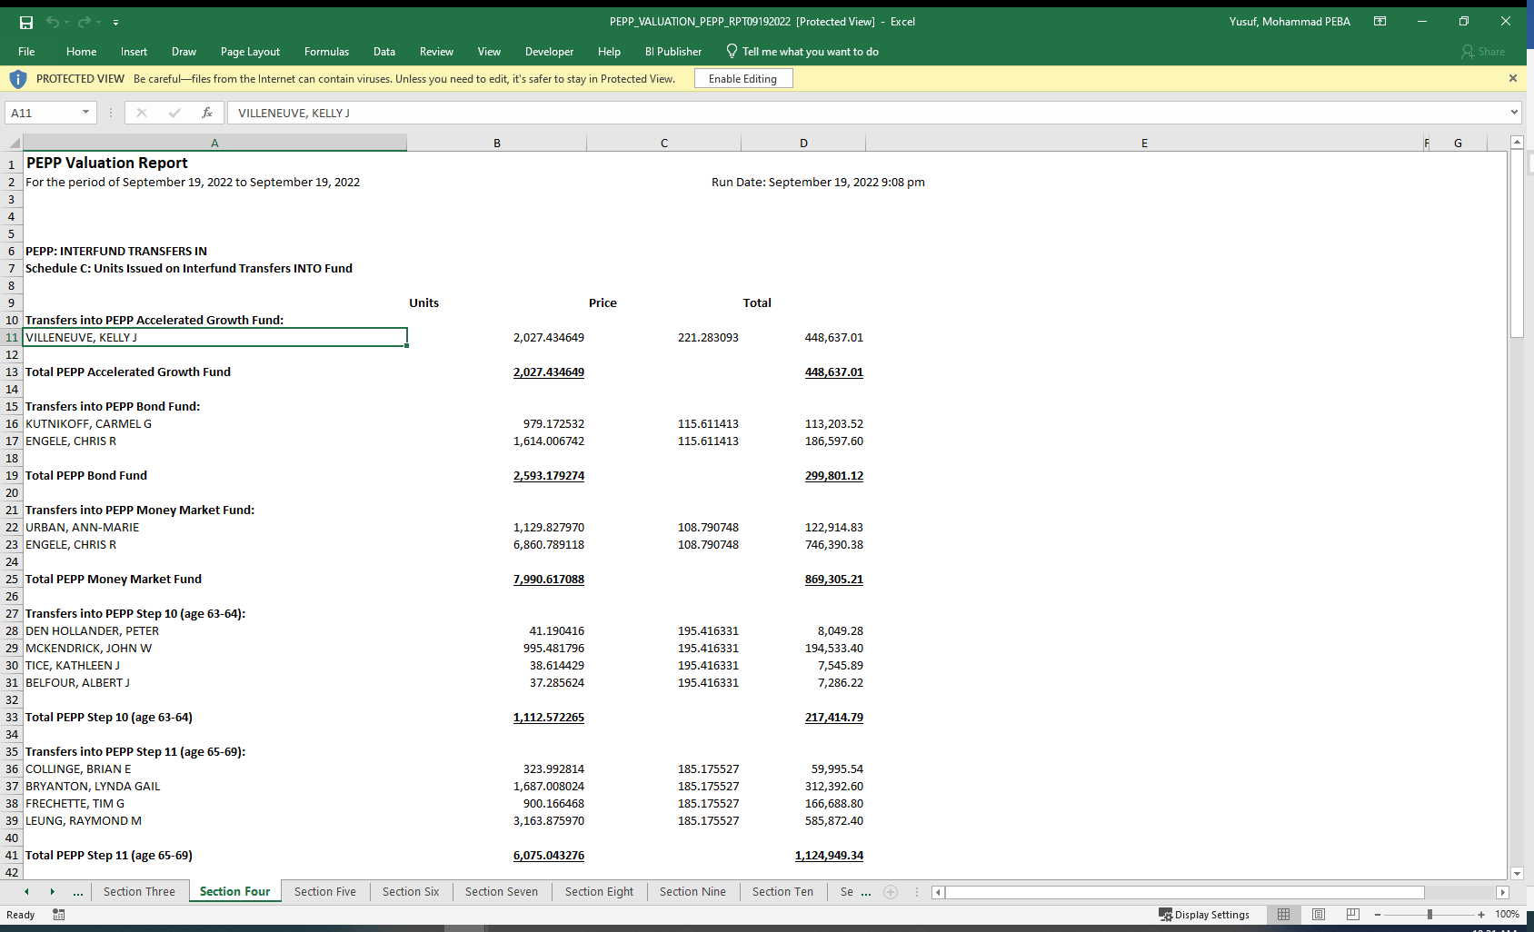

Section Nine (Transfer Out)

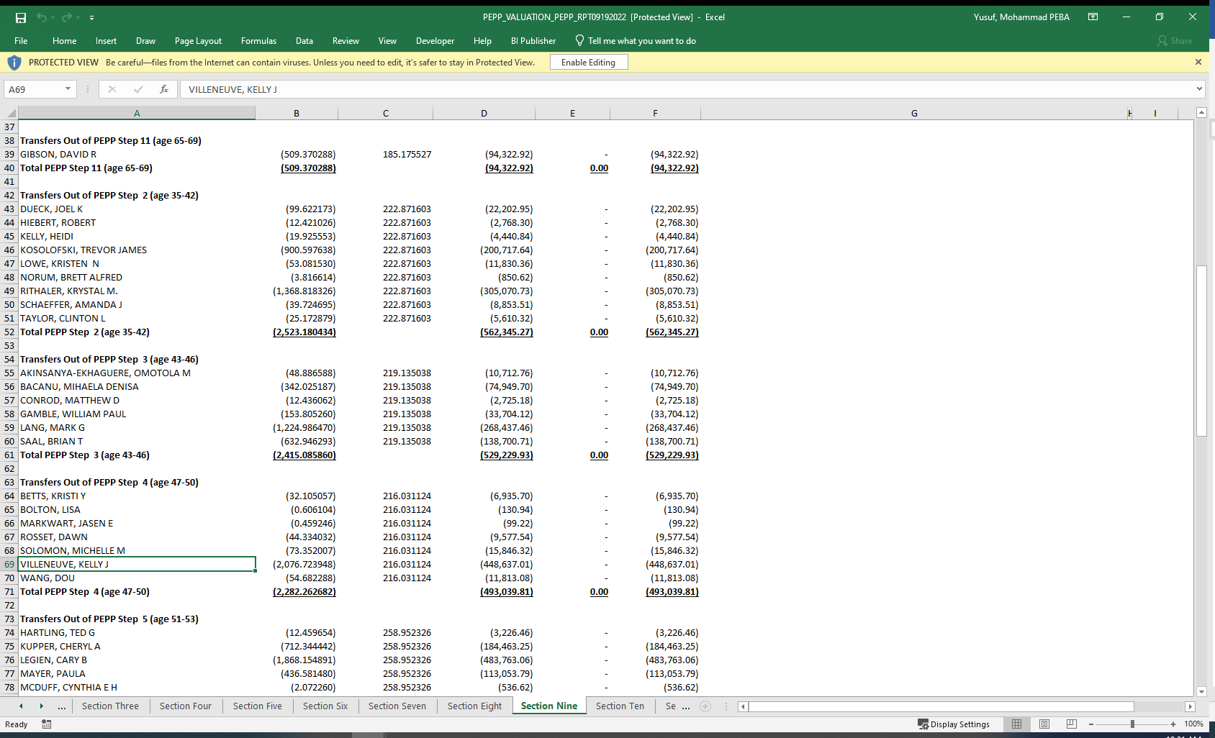

1. Member PLANet -> My Investment -> PEPP Account

